GOOGLE CLOUD LAB EXPERIMENTS(1-5)

Name:Tharunkumar.S
Regno:192511416
Coursecode:CSA-1516
Coursename:CLOUD COMPUTING

1. Execute a Python Program in Google Cloud Shell
Aim: Run a Python application using a cloud-based environment.
Steps:

- Open Google cloud Console

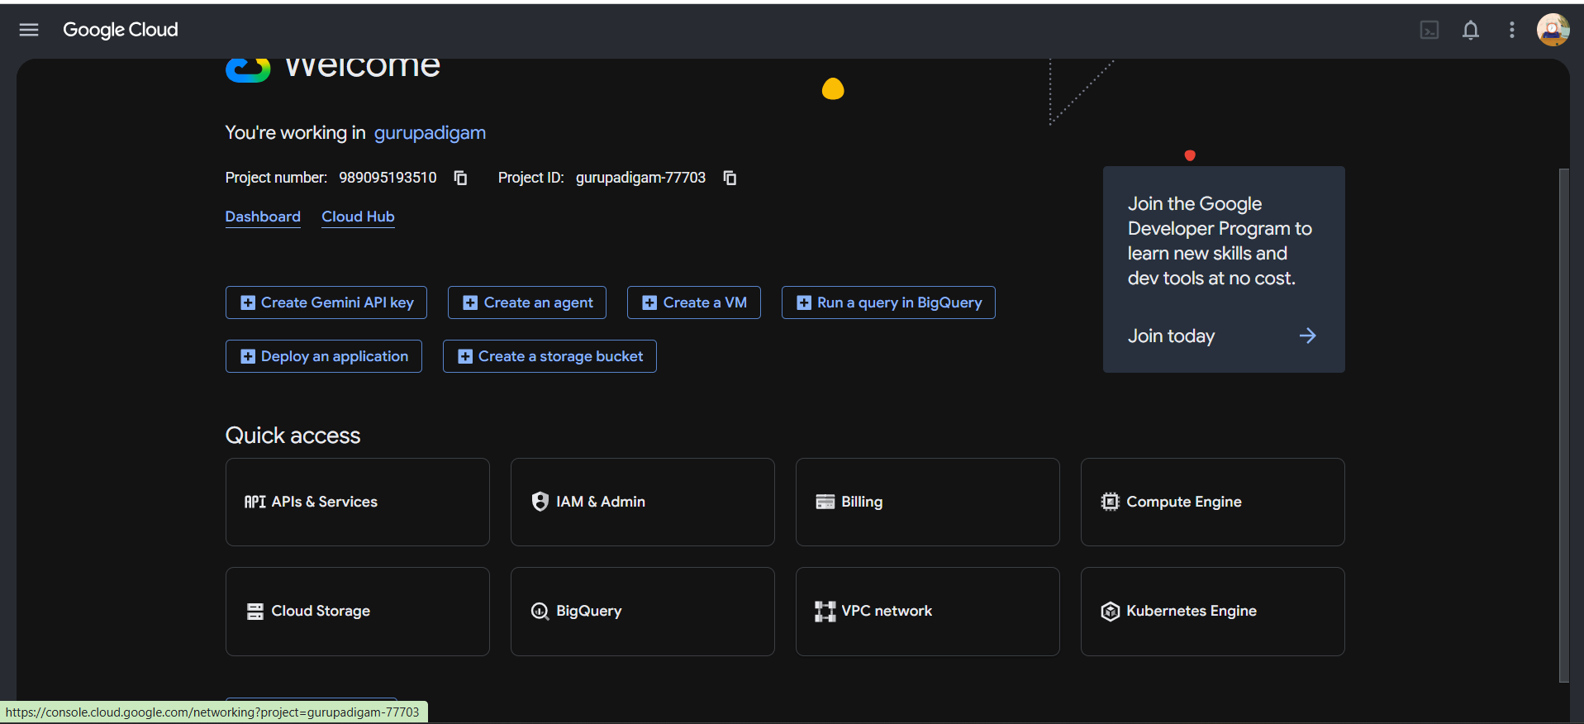

- Activate cloud shell console 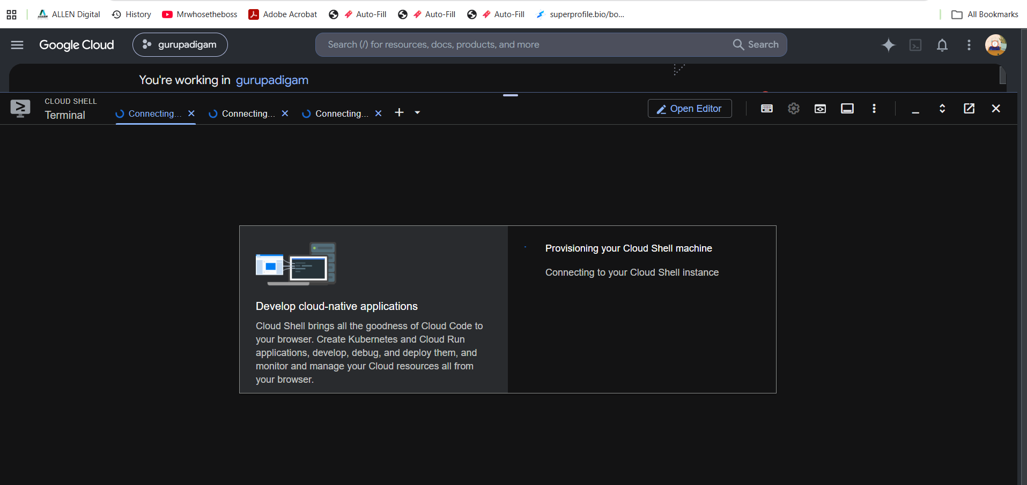

- nano command
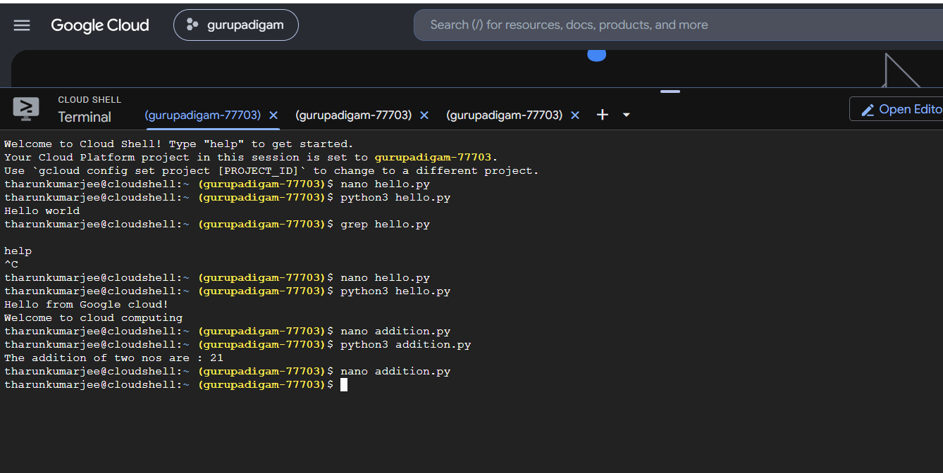

4.Python coding

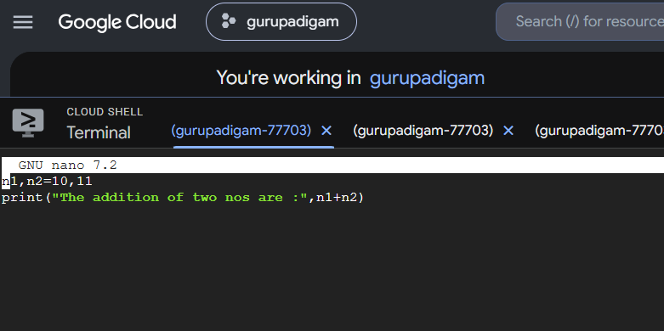

2. Create and Manage Files in Cloud Storage of Cloud Shell
Aim: Demonstrate cloud-based file creation and management.
In Cloud Shell:
mkdir cloudlab
cd cloudlab
echo "Welcome to Google Cloud" > sample.txt
cat sample.txt
Check files:
ls
Copy the file:
cp sample.txt backup.txt
Then:
Ls

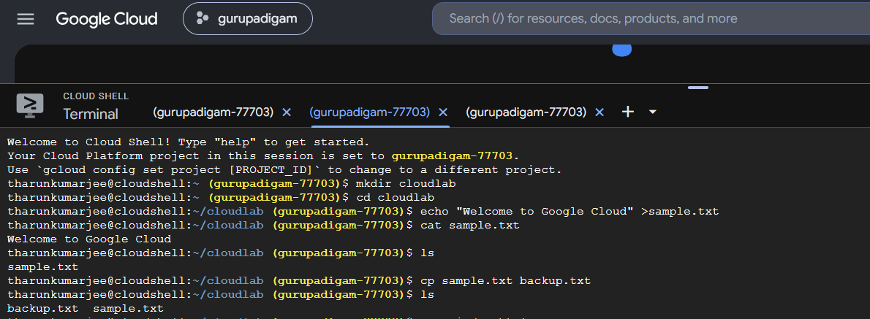

3. Run a Simple Web Server in Google Cloud Shell
Aim: Host and access a simple webpage from a cloud development environment.
Create HTML:
nano index.html
Enter:
<html>
<body>
<h1>Google Cloud Practical</h1>
<p>My first cloud web application</p>
</body>
</html>
Save and execute:
python3 -m http.server 8080
Then click Web Preview → Preview on port 8080 in Cloud Shell.
The webpage opens in the browser.

Step:1 Type nano index.html in in google cloud shell terminal

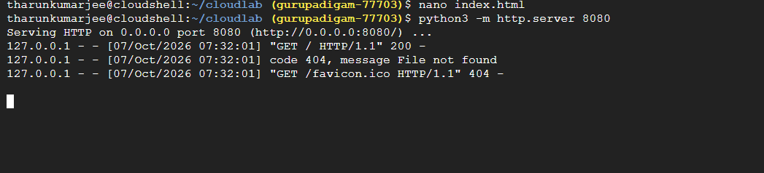

Step2: After that write index.html file

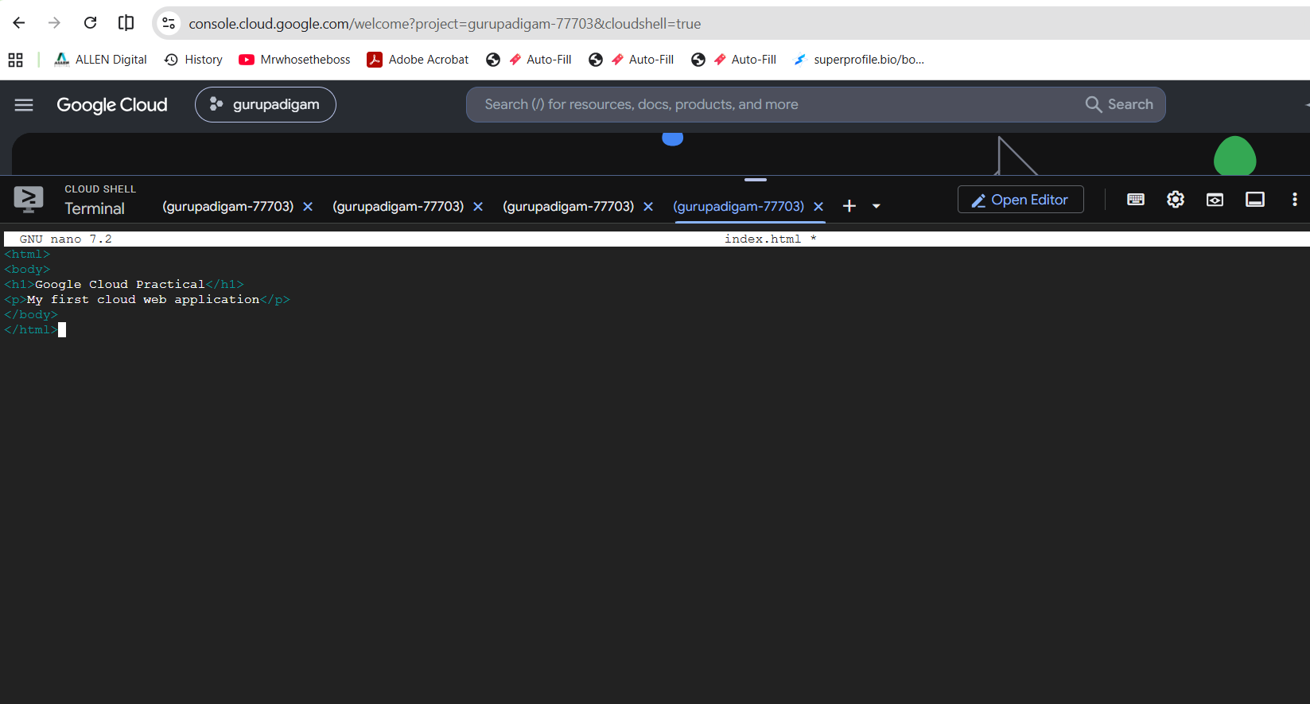

Step3: Click the link http://0.0.0.0:8080/ and static html webpage will be loaded

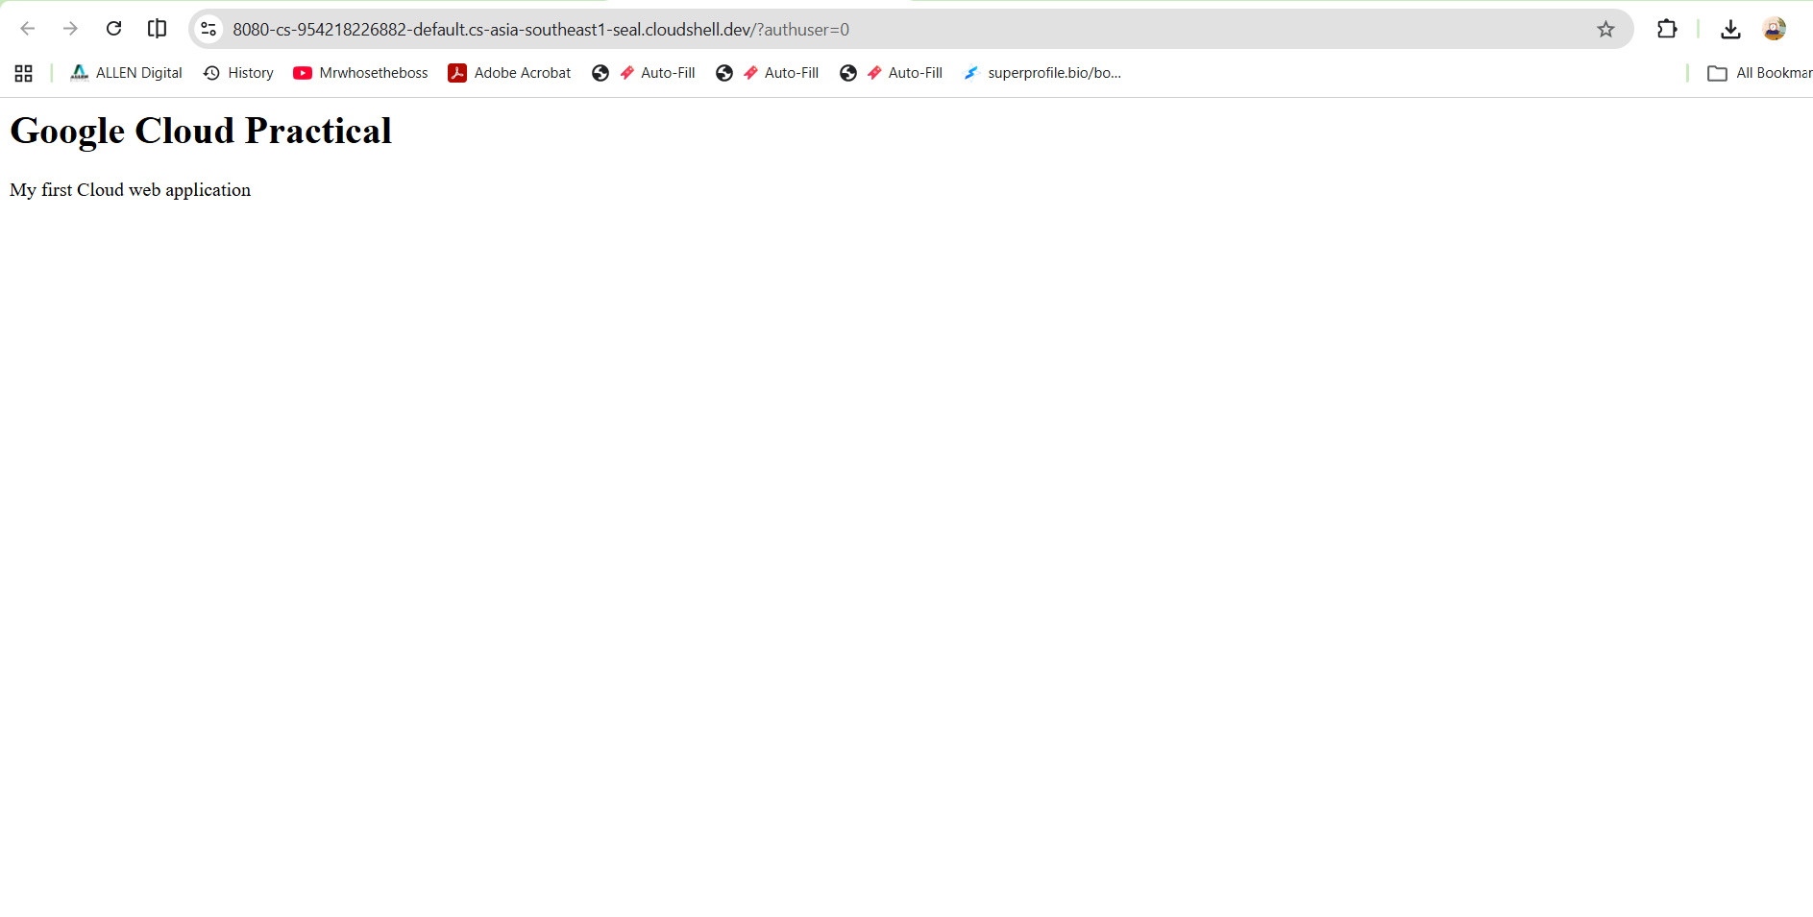

4. System Resource Monitoring in Google Cloud Shell
Aim: Demonstrate monitoring of CPU, memory and storage resources in a cloud environment.
Open Cloud Shell and execute:
free -h
Shows RAM usage.
df -h
Shows storage/disk usage.
lscpu
Shows CPU information.
Finally:
top
Shows running processes and CPU/memory utilization.
Press q to exit.

Type the above given commands in in google cloud shell terminal
1.free-h

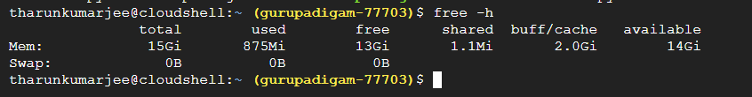

2.df -h

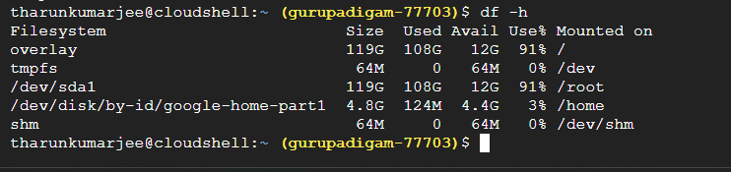

3.lscpu

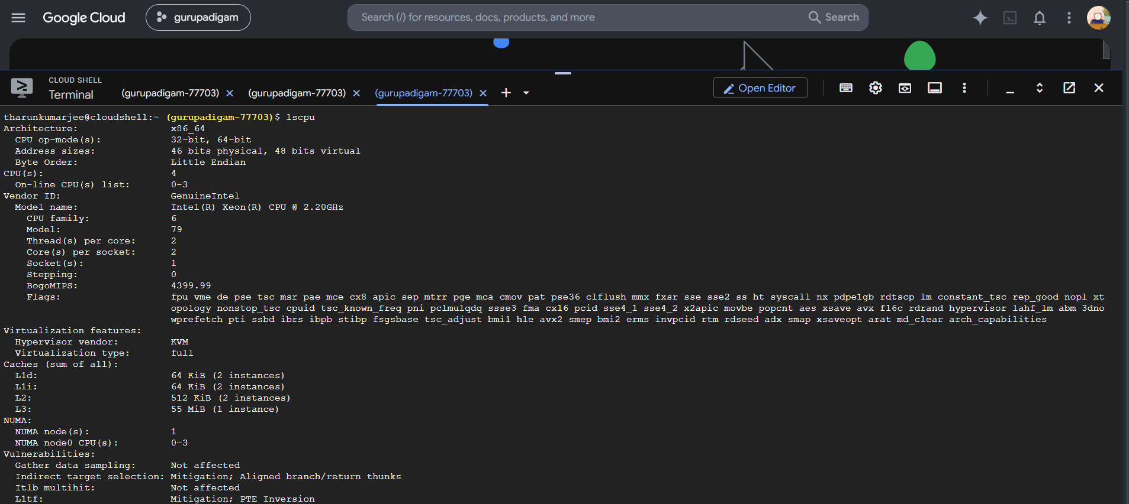

4.Top Command
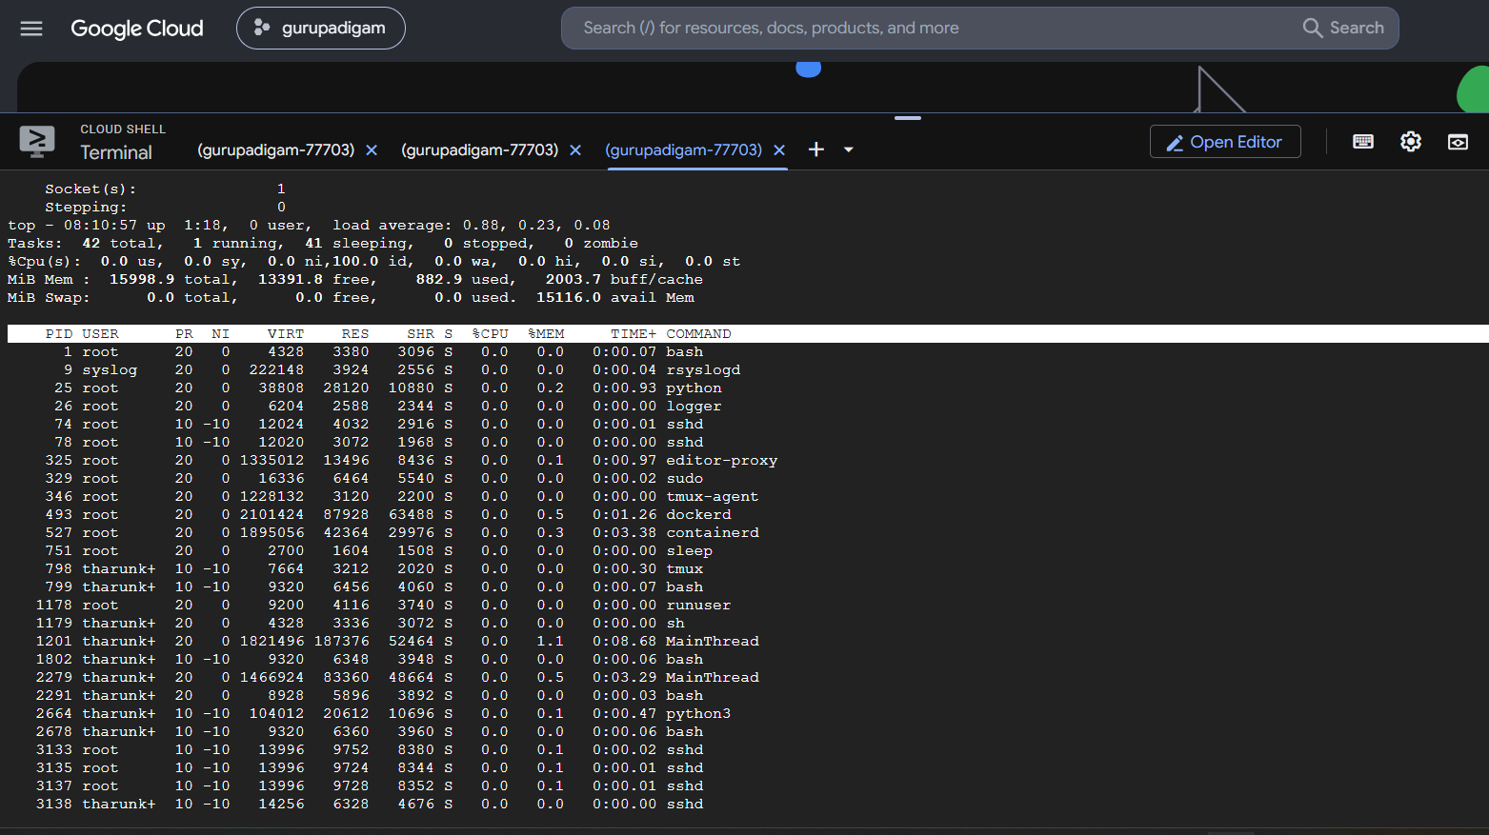

5. Execute a C Program in Google Cloud Shell
Aim: Compile and execute a C application in a cloud-based environment.
Create program:
nano add.c
Enter:
#include <stdio.h>

int main()
{
int a = 10, b = 20;
printf("Sum = %d\n", a + b);
return 0;
}
Compile:
gcc add.c -o add
Run:
./add

Output:
Sum = 30

Step:1 Open cloud shell Terminal and type the command nano add.c

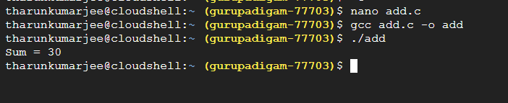

Step:2 After this cloud editor will open then execute c program in that editor

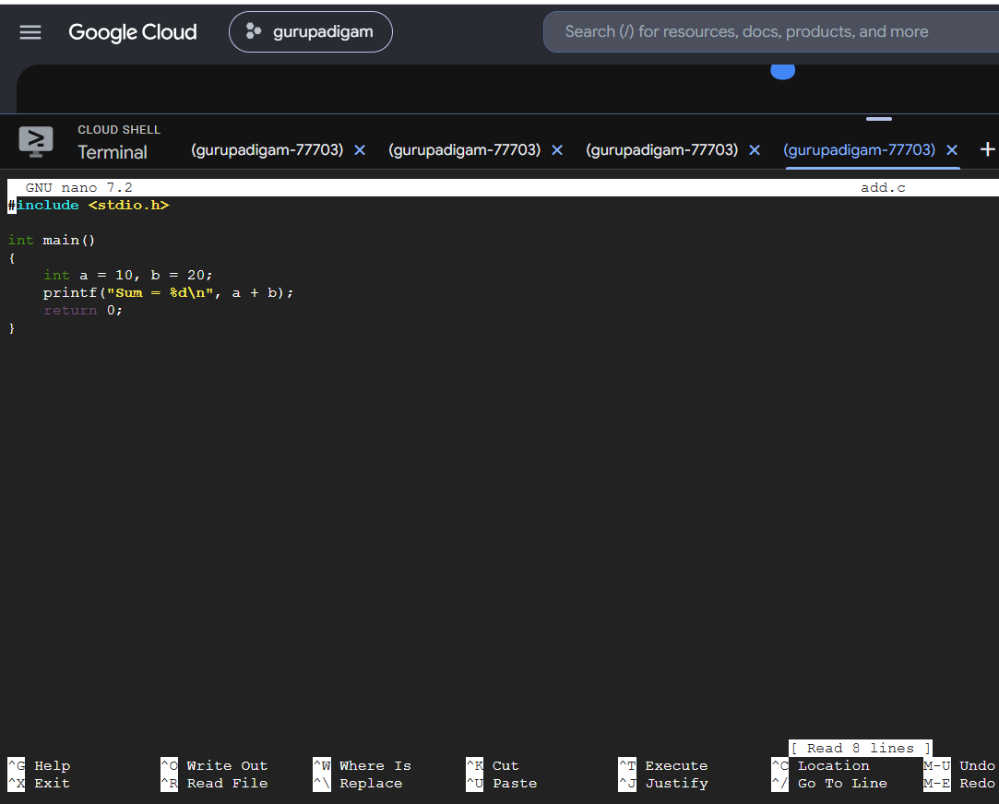
Step 3: Give control+o The press enter then press control+X to save and come cloud shell terminal and the compile and run the code and output will be displayed

